**Getting Started**

From the following link:

<https://dev.mysql.com/downloads/mysql/>

You can choose the operating system and then click on **GO to Download Page.**

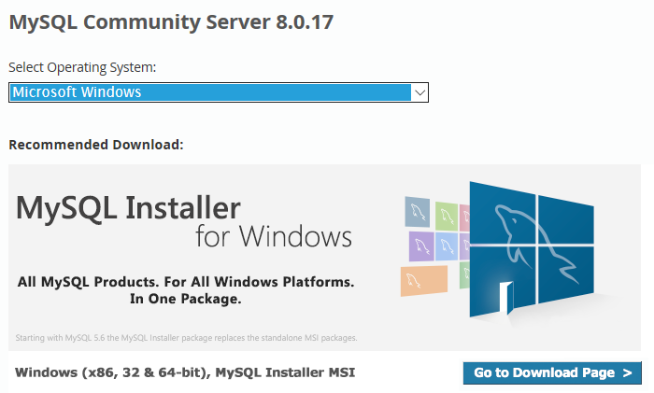

In the **Download MySQL Installer** page, choose the second option.

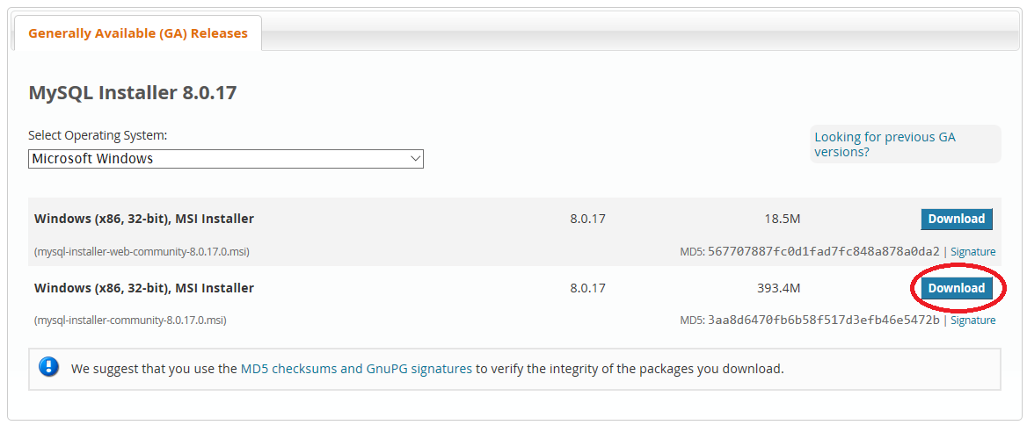

If you do not have an Oracle web account, you can start downloading the installing without signing up.

|  |
| --- |
|  |

When the download is complete, execute the installer. At the time you install MYSQL server, a newer version may be available.

After accepting the License Agreement (you need to read and accept it) In the MySQL installer Welcome page, just click **NEXT**.

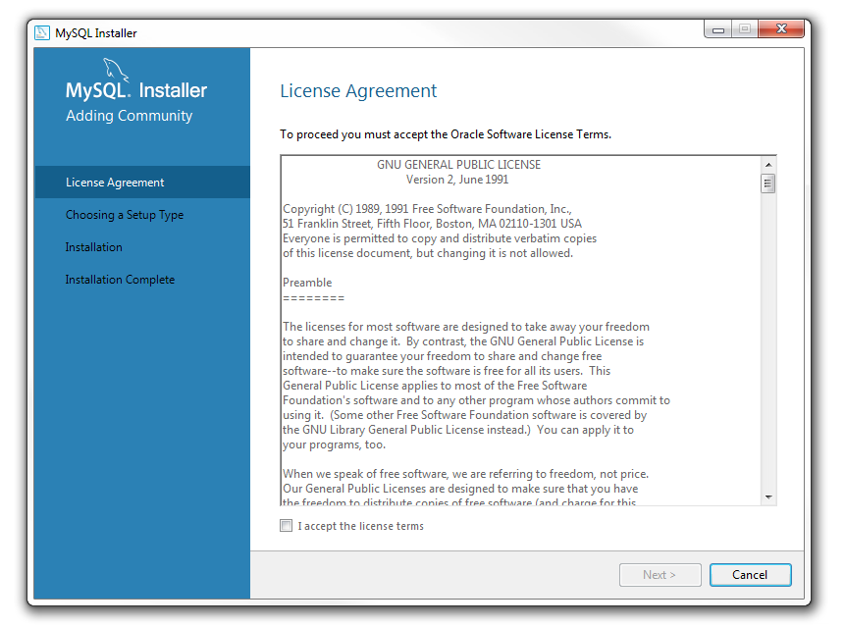

Keep all options as default.

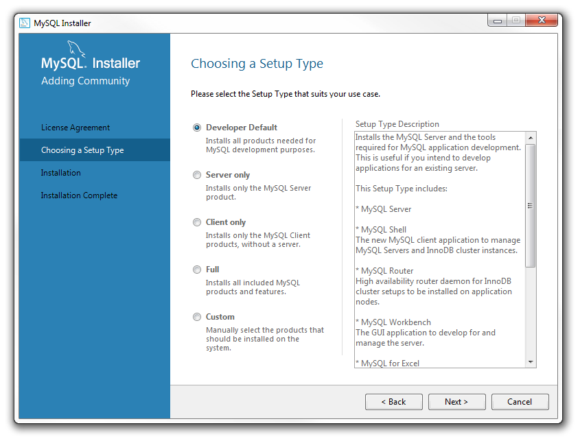

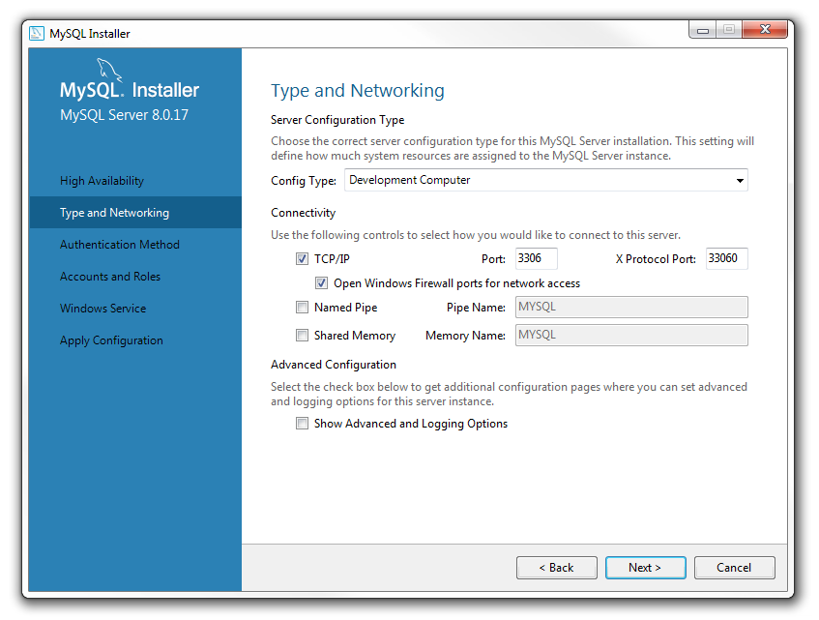

In the Accounts and Roles page, enter a password for the root account.

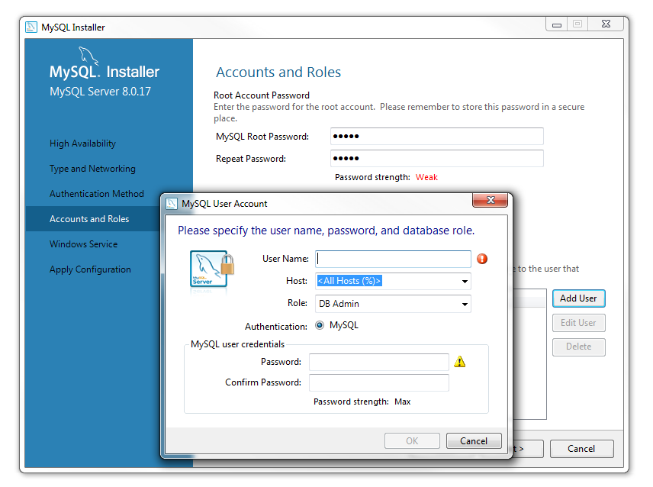

You can also define more users here by selecting **Add User**. For instance, you can create an account with the DB Admin role and use this account on your local server to work with MySQL server.

To work with MySQL server, you can run **MySQL Workbench** or **MySQL Command Line Client**.

